

**NEW WEEKLY JOB POSTINGS FROM   
HELP WANTED ONLINE  
Office of Research**

**Week Ending February 25th, 2023: New Ads fall to lowest weekly levels of 2023.**WETHERSFIELD, March 3rd, 2023 – During the week ending February 25th, there were 5,829 new postings, down 1,148 new ads or -16% from a week ago. Most of this decline occurred in Health Care & Social Assistance (-273 new ads), Professional, Scientific, & Technical Services (-238 new ads), and Manufacturing (-157 new ads). Employers with the largest over-the-week declines in those respective industries were Aya Healthcare (-34 new ads), General Dynamics (-33 new ads), and Accenture (-12 new ads). Occupations with the largest decreases over the week were Registered Nurses (-143 new ads), Wholesale & Manufacturing Sales Representatives (-55 new ads), and Software Developers, Applications (-47 new ads). The most recent week of new ads is the lowest level of 2023, the -16% over-the-week change is the largest drop since the end of December 2023, which had a -40% over-the-week change. Nationally, total new ads were down 19% over the week.  
  
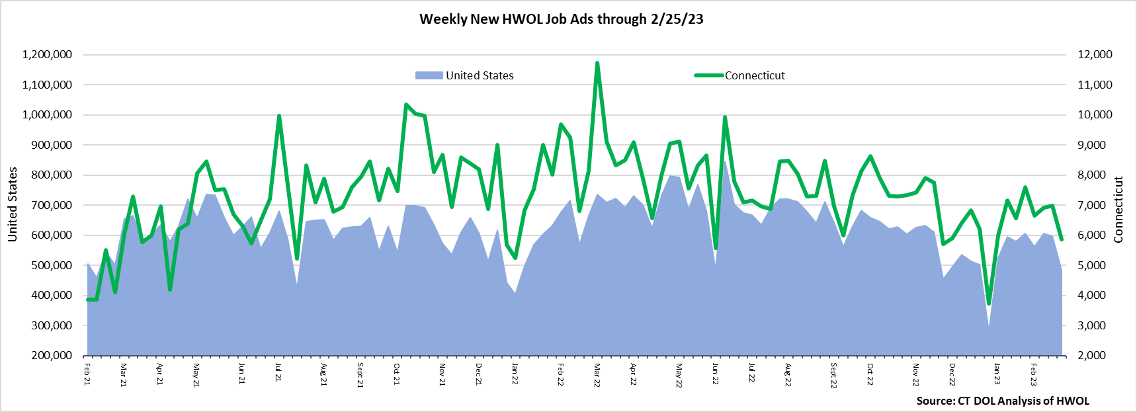  
**Industries** with the most new postings include Health Care & Social Assistance, Finance & Insurance, and Retail Trade.

**Occupations** with the most new postings include Registered Nurses, Retail Salespersons, and Managers.

**Employers** with the most new postings include Travelers, Hartford Healthcare, and Cigna Corporation.

**The three industries with the most new job postings were:**

* **Health Care & Social Assistance** (1,449 new postings, -16% over the week)
* **Finance & Insurance** (535 new postings, +9% over the week)
* **Retail Trade** (456 new postings, -11% over the week)

   
 During the week ending February 25th, 2023, the 1,148 new ad decrease is the net result of industry-level declines in 17 of 21 industries. More than half the overall decrease occurred in Health Care & Social Assistance (-273 new ads), Pro., Sci., & Tech. Services (-161 new ads), and Manufacturing (-157 new ads). The over-the-week drop to 5,829 new ads is the lowest level of 2023. The most recent week of new ads was the lowest level of 2023 for 7 out of 10 industries with the most ads.  
  
  
 For more information on total job ads by industry for Connecticut and its labor market areas, see the monthly report available here: <https://www1.ctdol.state.ct.us/lmi/hwol.asp>

**New Job Postings by Occupation** 

**The occupations with the most new postings were:**

* Registered Nurses (372 new postings, -28% over the week)
* Retail Salespersons (146 new postings, -10% over the week)
* Managers (138 new postings, -23% over the week)

**Employers with the Most New Job Postings** Employers with the most new job postings during the week were mostly within Health Care & Social Assistance, Finance & Insurance, and Education. Healthcare & Social Assistance accounted for eleven of the top 25 employers. The 25 employers shown above combined account for 1,356 job ads or 23 percent of all new ads. Thirteen employers in the top 25 had over the week increases, the largest occurred at Travelers (+187 new ads), Hartford Healthcare (+104 new ads), and Cigna (+68 new ads). Among the 25 employers with the most ads during the week ending February 25th, the largest over the week declines occurred at Lumen Technologies (-181 new ads).   
  
  
**What is HWOL?**The **Conference Board Help Wanted Online**® Data Series (HWOL) measures the number of new, first-time Online job postings and jobs reposted from the previous month for over 16,000 Internet job boards, corporate boards, and smaller job sites that serve niche markets and smaller geographic areas. To view more HWOL data, go to: <https://www1.ctdol.state.ct.us/lmi/hwol.asp>